DriverURLInfo.robot

The below file contains driver information and URL for login and close the browser keyword for closing the browser

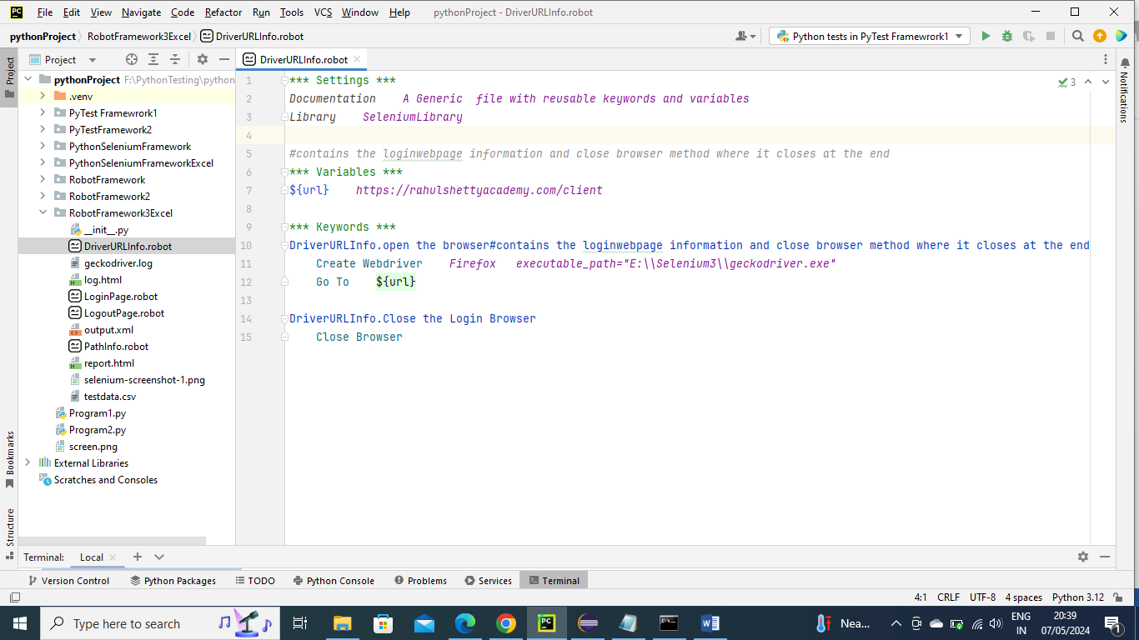

PathInfo.robot

The below file contains all the info about locators

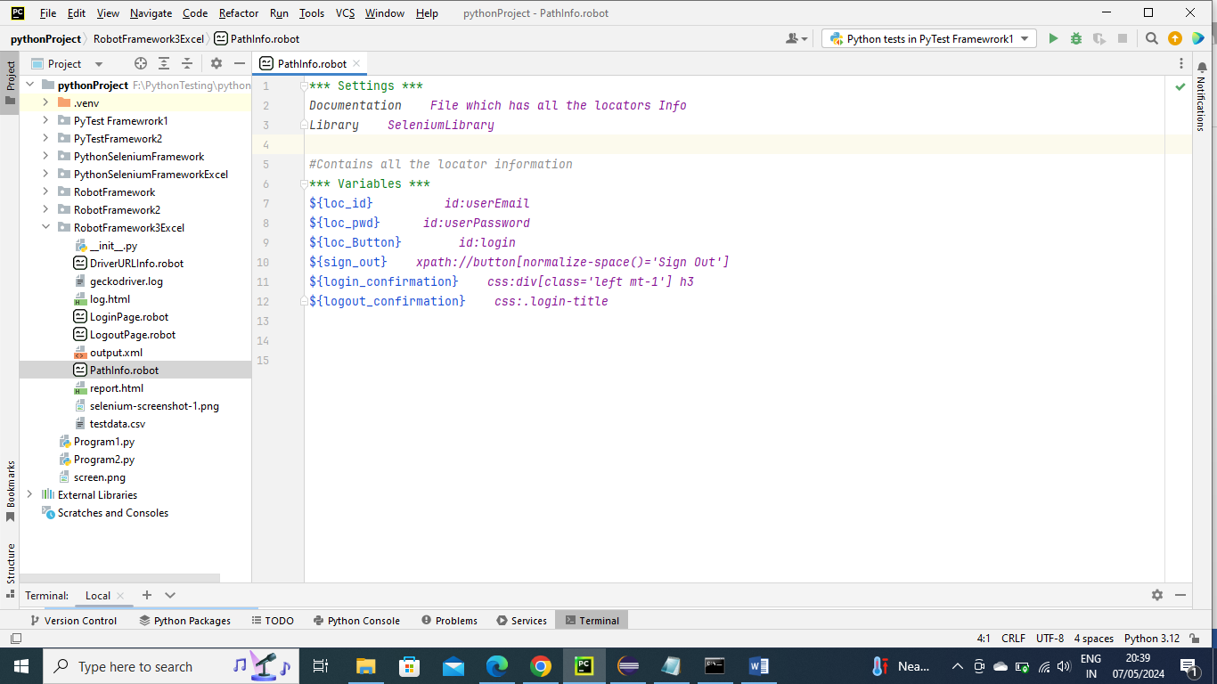

Testdata.csv

The below contains the test data in form of csv for login

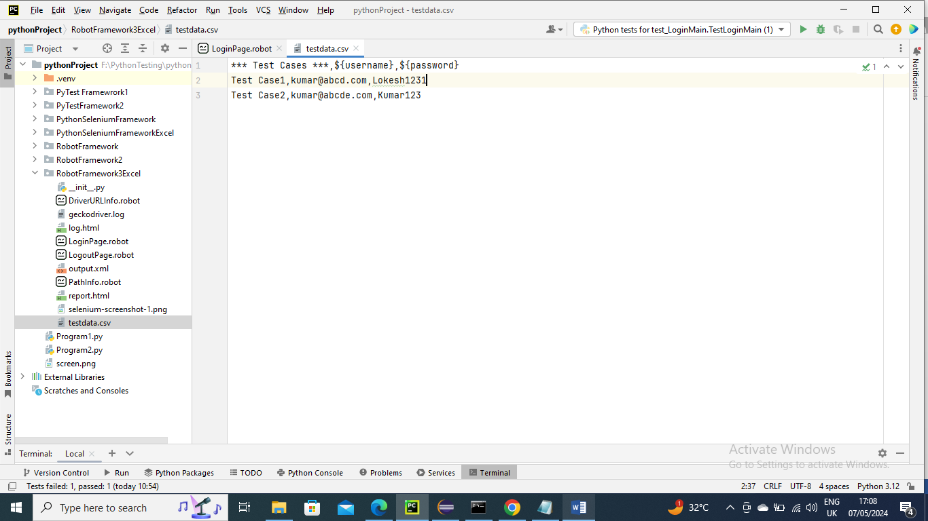

LogoutPage.robot

The below file contains the logout locator info and also verification keyword for it to complete fastly

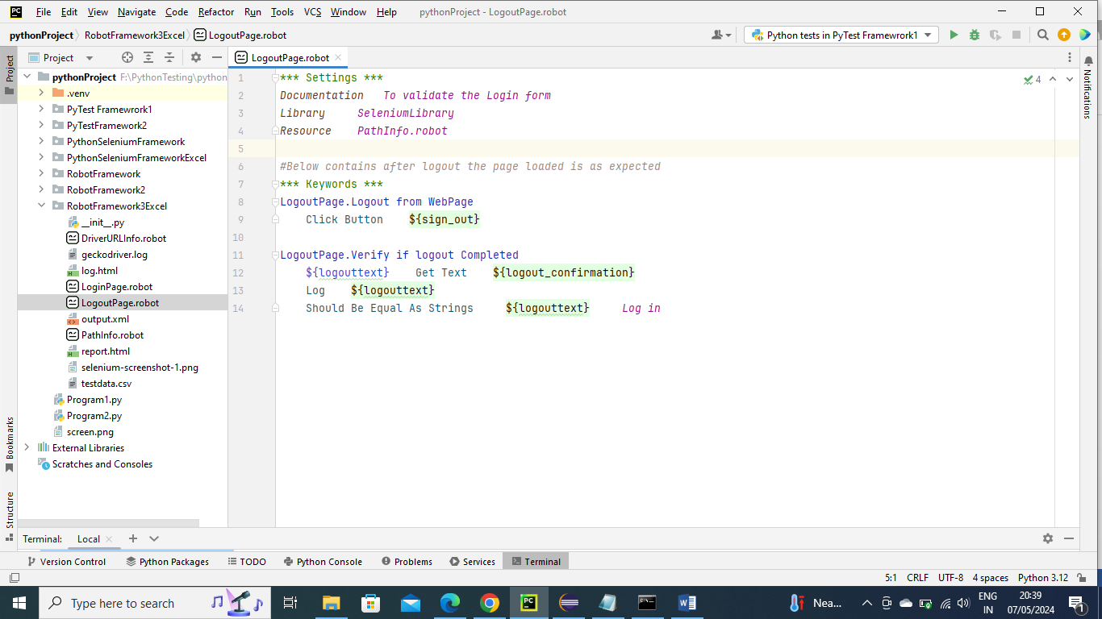

LoginPage.robot

The below main program calls driver info my giving it Test setup and this program passes parameters to different keywords for login and verification from the csv data and then logout automatically done by using test Teardown.

Let’s say if no data exist in csv then it will pick the default credentials in the program

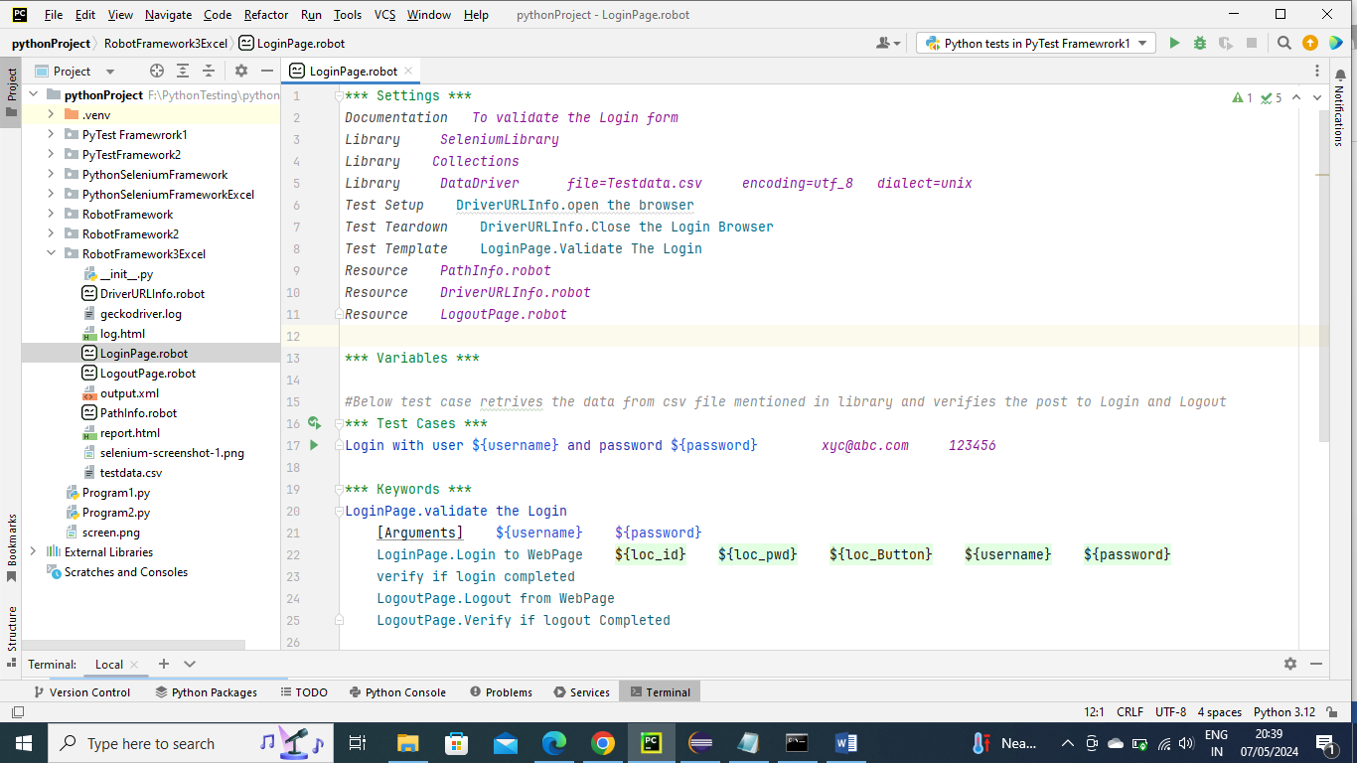

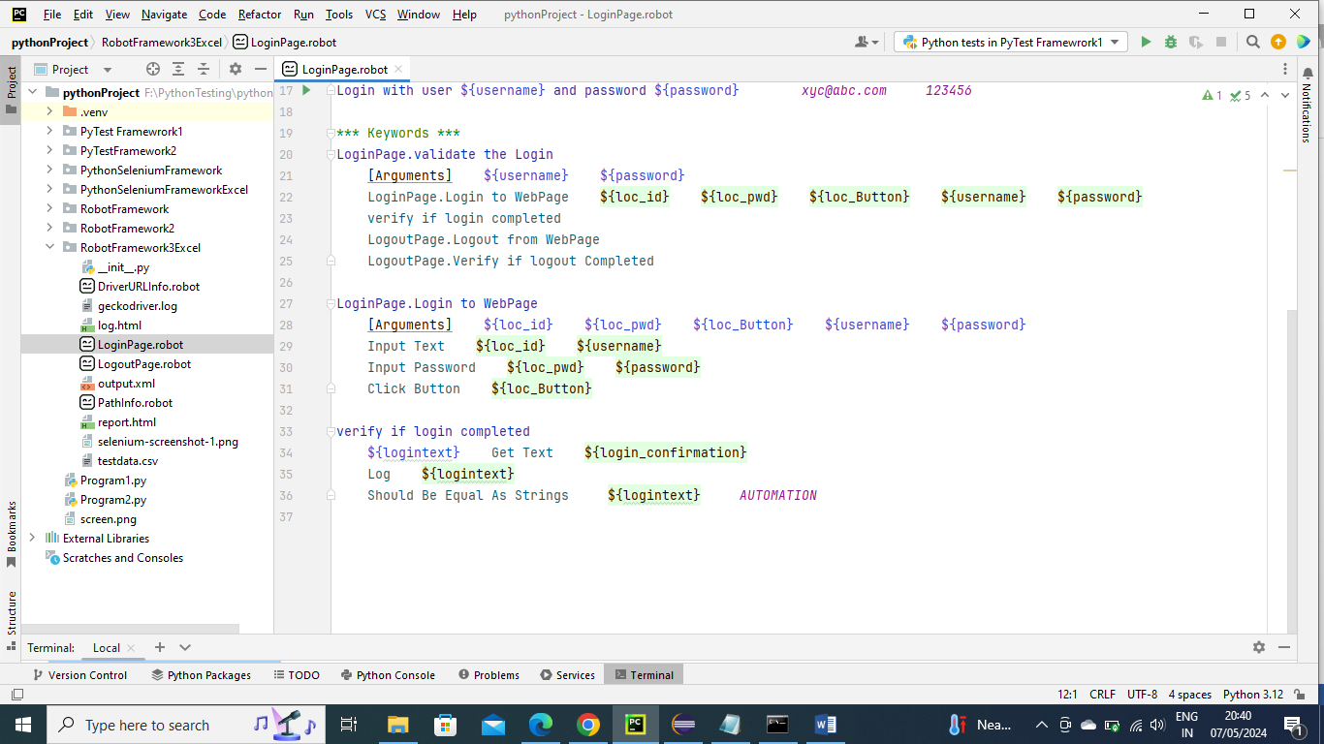

report.html

The below report file is generated by Robot Frame work automation inbuilt directly

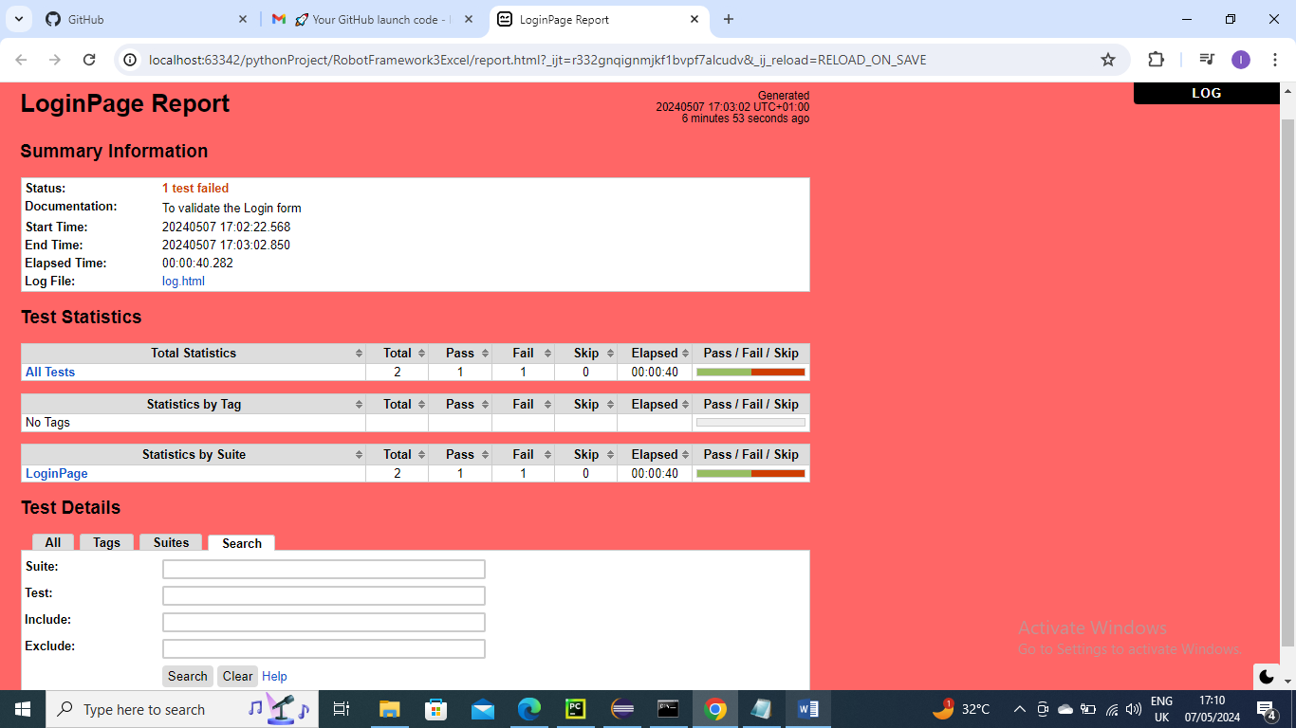

log.html

The below html file is generated by Robot Frame work automation inbuilt directly only

Here the screenshot also embedded automatically

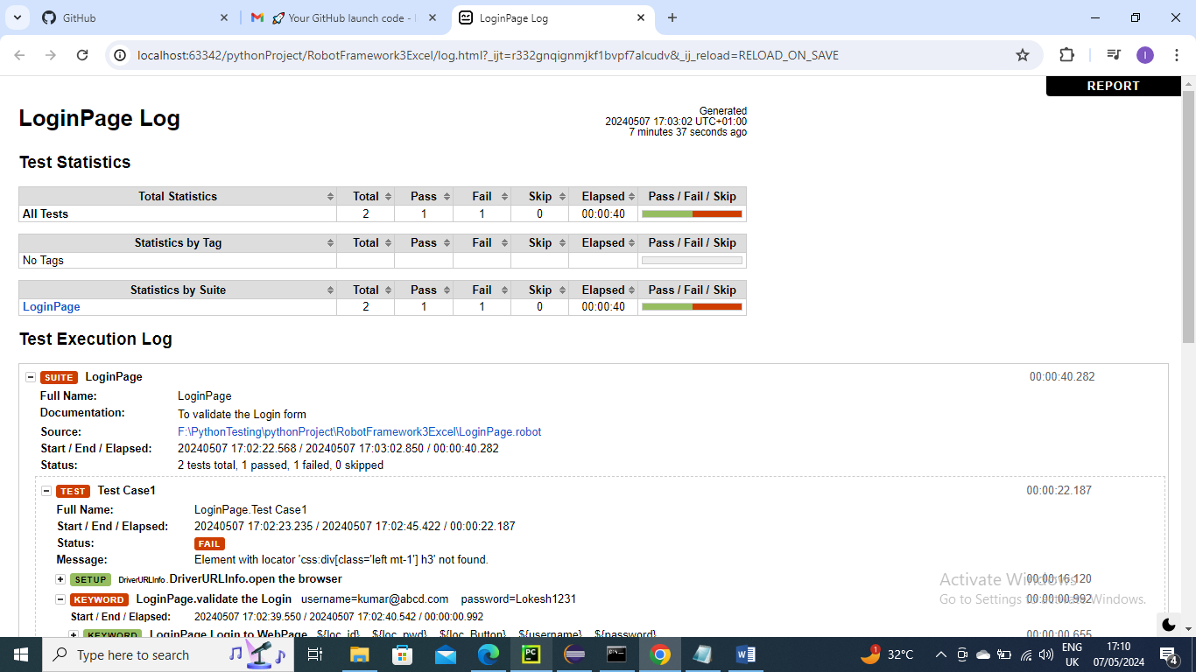

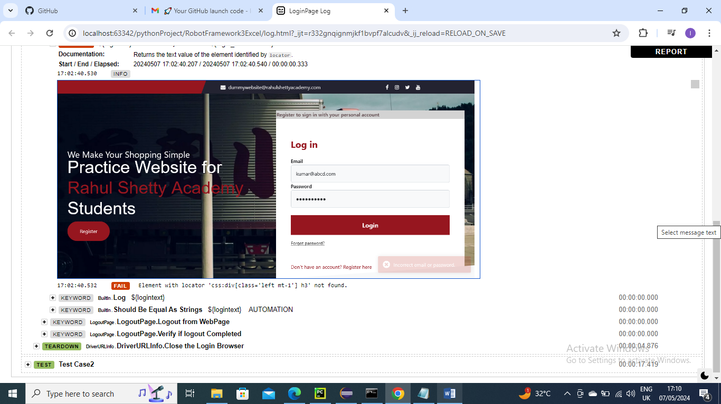

output.xml

The below Output file is generated by Robot Frame work automation inbuilt directly only

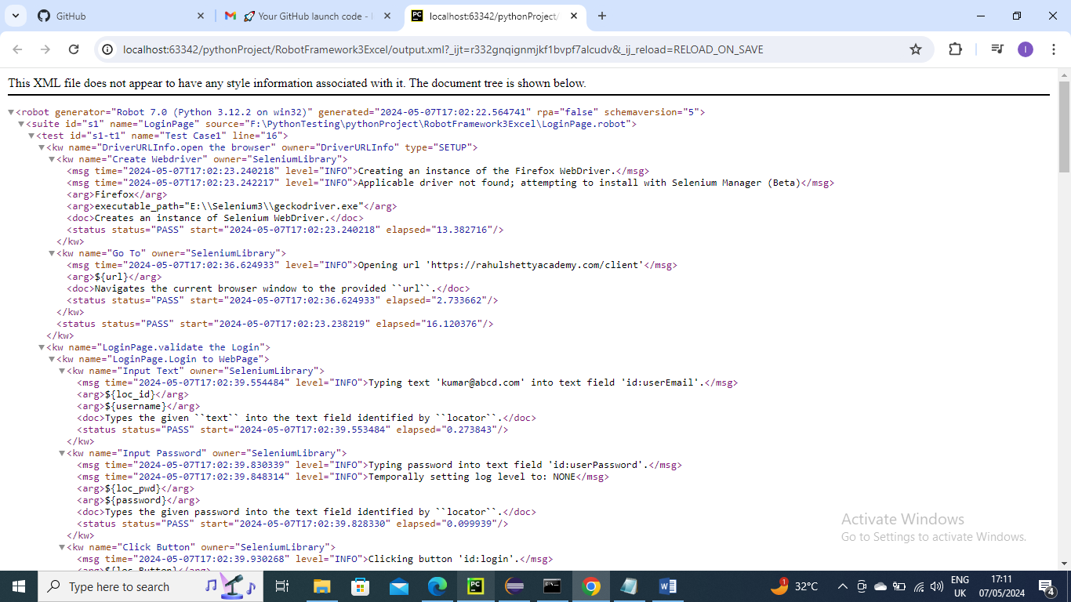

Generates screenshot in project folder as well for failed ones. Below is for reference

